"For You have made us for Yourself, O Lord, and our heart is restless until it finds its rest in You"
St. Augustine of Hippo


The value of mankind is at once inherent and enigmatic, a nagging mystery that always begs the question: Was I really created for something more? Though my present quests in life may afford me a certain level of fulfillment, could I possibly be "missing the mark" after all?
The answer lies in the life and death of another - the person of Jesus Christ. Scripture says, "In Him is light, and His light is the life of man (John 1:4,)" a light so shine into our empty spaces to awaken us to a love unknown. Through Jesus' sinless life and sacrifice on the cross, we see the love of God cries out in forgiveness and longing, and Jesus, whom we had so often dismissed, is in fact the "joy of man's desiring," the very One whom our heart yearns all along.
The glory veiled, but God is the One who "give[s] the light of the knowledge of the glory of God in the face of Jesus Christ." We hope you will heed God's invitation and come to know the joy of your heart's true desiring.

Join us onsite at 146-29 Laburnum Ave, Flushing, or via Zoom

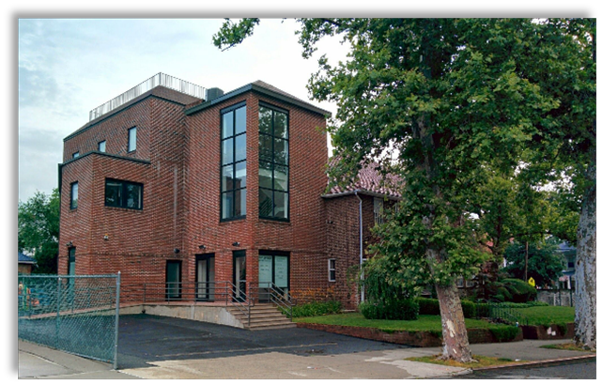
on

October 25th, 2025 5:00pm
(Light dinner provided afterward)

