"In Him is life, and His life is the light of man"
John 1:4

Have you ever wondered —

Was I really created for something more?
Though my present quests in life may afford me a certain level of fulfillment, could I possibly be “missing the mark” after all?
St. Augustine of Hippo (354-430 AD) said;
“For You have made us for Yourself, O Lord, and our heart is restless until it finds its rest in You”
The good news is that there is an answer — and it’s found in a Person — Jesus Christ
He is the light that shines into our empty spaces, awakening us to a love beyond anything we’ve known.
Join us for a Good News Meeting followed by dinner to hear more about Jesus, the “joy of man’s desiring” — the true desire of every heart.

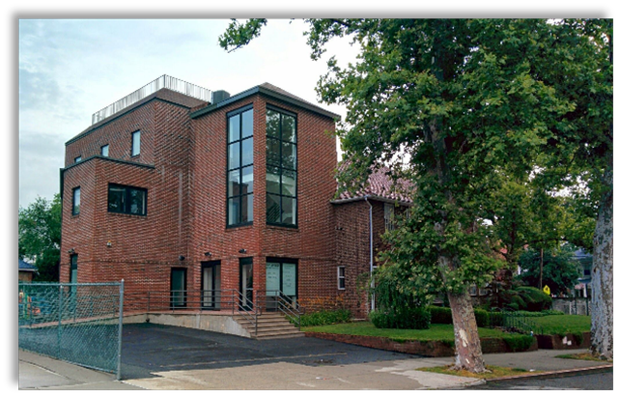
You may attend the meeting at 146-29 Laburnum Ave, Flushing, or via the Zoom link found on our webpage


on
October 25th, 2025 5PM www.cbmministry.org/gospel

