The Anchor of Your Life 一生的依靠!

Jesus is the “I am.”
He is all that you will ever need.
Are you spiritually hungry?
He said, “I am the bread of life.”
Are you thirsty for something more satisfying in your life?
He said, “I will be a well of water for you.”
Are you afraid of death?
He said, “I am the resurrection and the life.”
Are you weary and heavy-burdened?
He said, “I will be your rest.”
Are you confused about life and don't know your way?
He said, “I am the way, the truth, and the life.”
Are you in the dark about what life is about?
He said, “I am the light of the world.”

Time/时间: 2019-07-21, Sunday 11:00AM周日上午11点
Place/地点: Christian Believers’ Meeting
146-29 Laburnum Avenue, Flushing, NY 11355
Tel/电话: 929-266-4295 or 516-234-0868
This hope we have as an anchor of the soul, both sure and steadfast. -Hebrews 6:19a
我们有这指望如同灵魂的锚,又坚固又牢靠 -希伯来6:19 《路加福音》5 章 27-28 節
For I am persuaded that neither death nor life, nor angels nor principalities nor powers, nor things present nor things to come, nor height nor depth, nor any other created thing, shall be able to separate us from the love of God which is in Christ Jesus our Lord. -Romans 8:38-39
因为我深信无论是死,是生,是天使,是掌权的,是有能的,是现在的事,是将来的事, 是高处的,是低处的,是别的受造之物,都不能叫我们与神的爱隔绝. - 罗马书8:38-39

2019 Summer Gospel Meeting in Flushing
法拉盛地區2019年夏季福音聚會

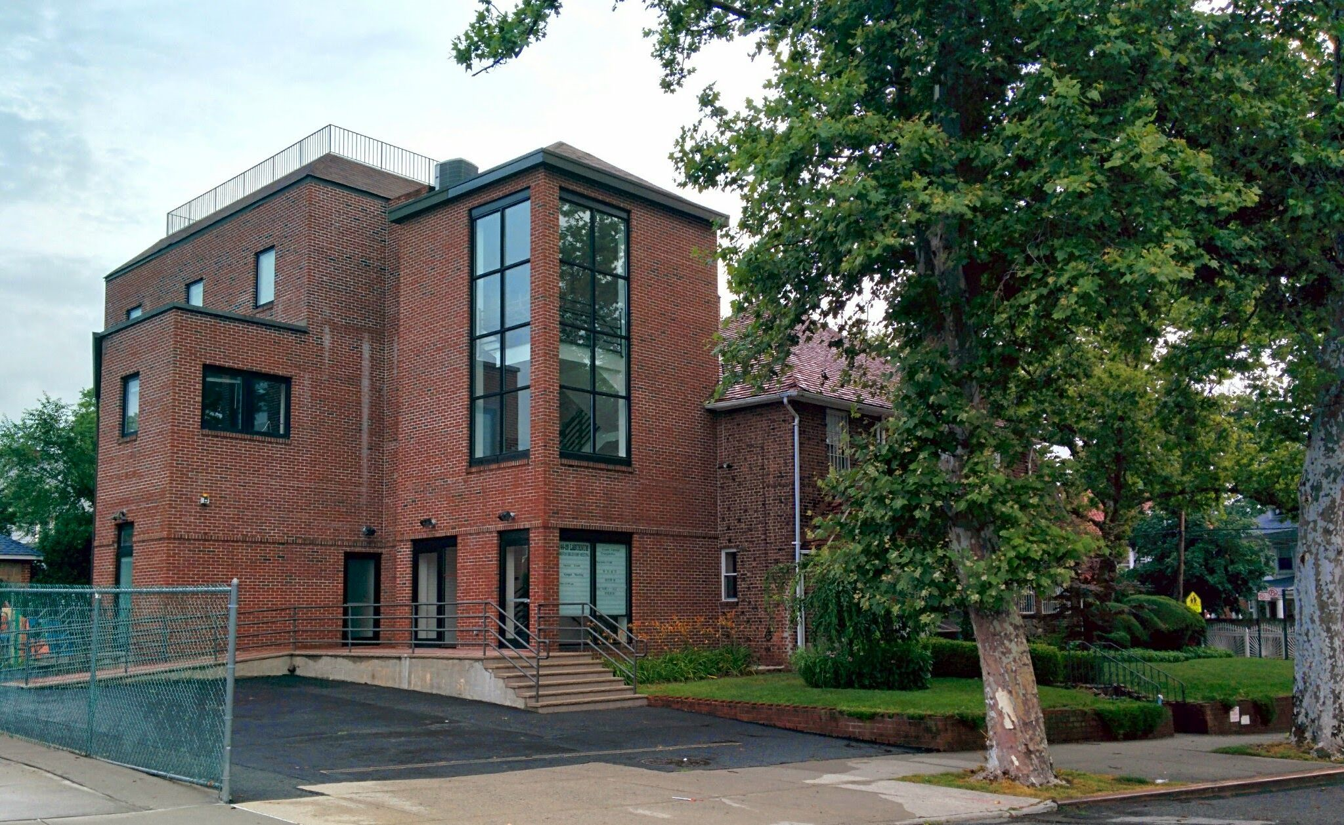
耶稣说：我是！
他是你永远所有的需要。
你是否觉得心中的空虚无法满足？
耶稣說，“我是生命的粮。”
你是否心灵干渴？
耶稣說：“我将成为你生命中活水的泉源。”
你是否畏惧死亡？
耶稣說：“我是复活和生命。”
你是否疲倦和不堪重負？
耶稣說，“我将是你的安息。”
你是否對生活感到困惑，不知道你的方向？
耶穌說，“我就是道路，真理，生命。”
你是否發現你在黑暗中不知生活為了什麼呢？
耶穌說，“我是世界的光。”

