You may have friends that you dearly cherish, but no friend will care for you like Jesus. He did for you and me what no one else can do.

Jesus knows you intimately
You have searched me, Lord, and You know me ... You discern my going out and my lying down; You are familiar with all my ways. [Psalm 139: 1, 3]

Jesus truly loves you
But God demonstrates His own love for us in this: While we were still sinners, Christ died for us [Roman 5:8]
Greater love has no one than this: to lay down one’s life for one’s friends. [John 15:13]

Jesus abides with you forever
Never will I leave you; never will I forsake you. [Hebrew 13: 5]

Jesus saves you to the utmost
I have come that they may have life, and have it to the full. [John 10:10]

There is no one like Jesus
No other so faithful and true!
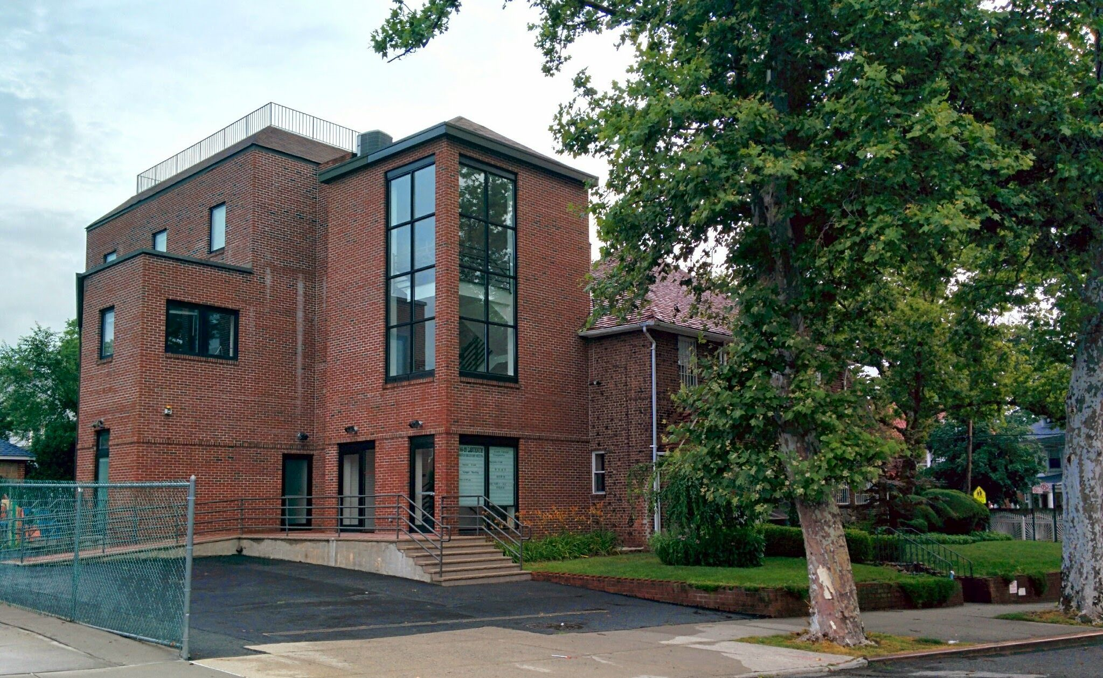
您或許有珍愛的朋友，但沒有一個朋友會像耶穌這樣愛你。他為你我所做的無他人可為, 他是真實可信的。

耶穌真的認識你
耶和華啊，你已經鑒察我，認識我... 我行路，我躺臥，你都細察；你也深知我一切所行的。[詩篇139:1,3]
耶穌真正愛你
惟有基督在我們還作罪人的時候為我們死， 神的愛就在此向我們顯明了。 [羅馬書5:8]
人為朋友捨命，人的愛心沒有比這個大的。 [約翰福音15:13]
耶穌永遠與你同住
因為主曾說：我總不撇下你，也不丟棄你。 [希伯來書13:5]
耶穌救你到底
我來了，是要叫羊（或作：人）得生命，並且得的更豐盛。 [約翰福音10: 10]
No Other Friend Like Jesus
沒有像耶穌的朋友

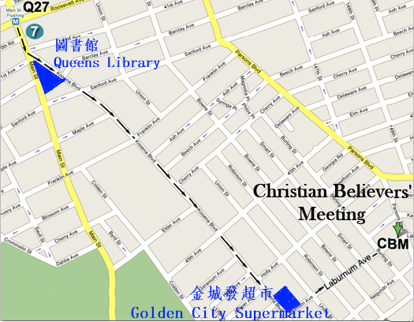
Greater love has no one than this: to lay down one’s life for one’s friends [John 15:13]
人為朋友捨命, 人的愛心沒有比這個大的 [約翰福音15:13]

2015 Spring Gospel Meeting in Flushing
法拉盛地區2015年春季福音聚會

Time/日期: 6/21/2015, Sunday禮拜天上午11:00AM
Place/地點: Christian Believers’ Meeting
146-29 Laburnum Avenue,
Flushing, NY 11355
Tel/電話: 516-234-0868

